Script Controlled ACL
Restrict Record Access Based on Field Values

4. Project Planning Phase
Objective
The planning phase organizes the implementation into a practical sequence. It ensures that the ServiceNow environment, table, records, users, ACL configuration, test cases, screenshots, and documentation are prepared before final demonstration.
Activities Performed
- Review and finalize the project objective and scope.
- Prepare the ServiceNow application and required table.
- Prepare sample records with different values in the selected control field.
- Prepare the required users, roles, or test accounts.
- Decide the ACL operation that will be controlled.
- Create a step-by-step implementation plan for the Scripted ACL.
- Prepare the script logic and define the expected true and false outcomes.
- Prepare positive and negative testing scenarios.
- Plan screenshot capture for the ACL configuration and test results.
- Prepare the final project documentation and demonstration sequence.
- Review the complete plan before moving to implementation.
Implementation / Detailed Description
In this phase, the project is handled in a structured manner so that the security requirement can be clearly configured and verified. The selected record field acts as an important input to the access decision. The ACL evaluates the current record during the access request and applies the configured condition. This approach makes it possible to distinguish between records that satisfy the security rule and records that do not satisfy it. The configuration should be validated carefully so that only the intended records are restricted.
Expected / Produced Output
The planned implementation sequence is: Environment Preparation → Requirement Setup → ACL Creation → Script Configuration → Test Data Preparation → Testing → Documentation → Demonstration.

Screenshots / Evidence
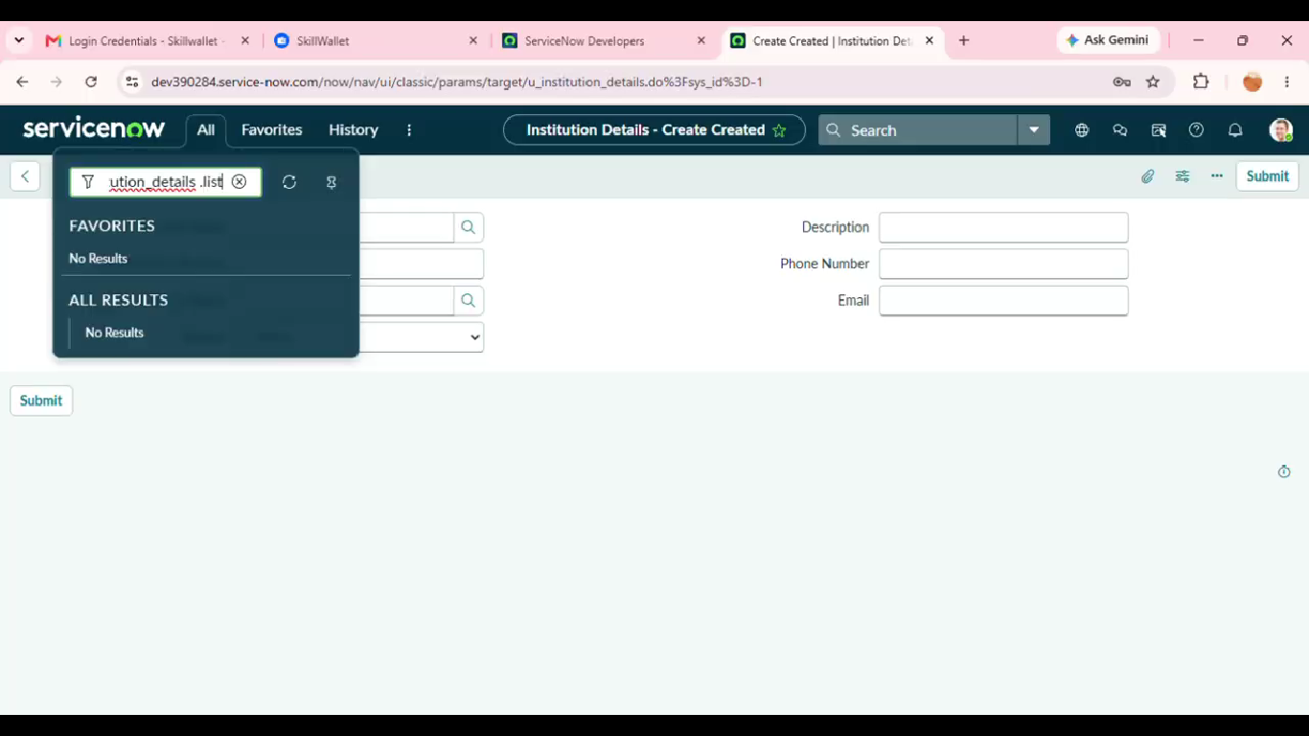

Result
The phase is completed after the configured activity is verified against the project requirement. The screenshots and test observations can be inserted in the spaces provided above as implementation evidence.

